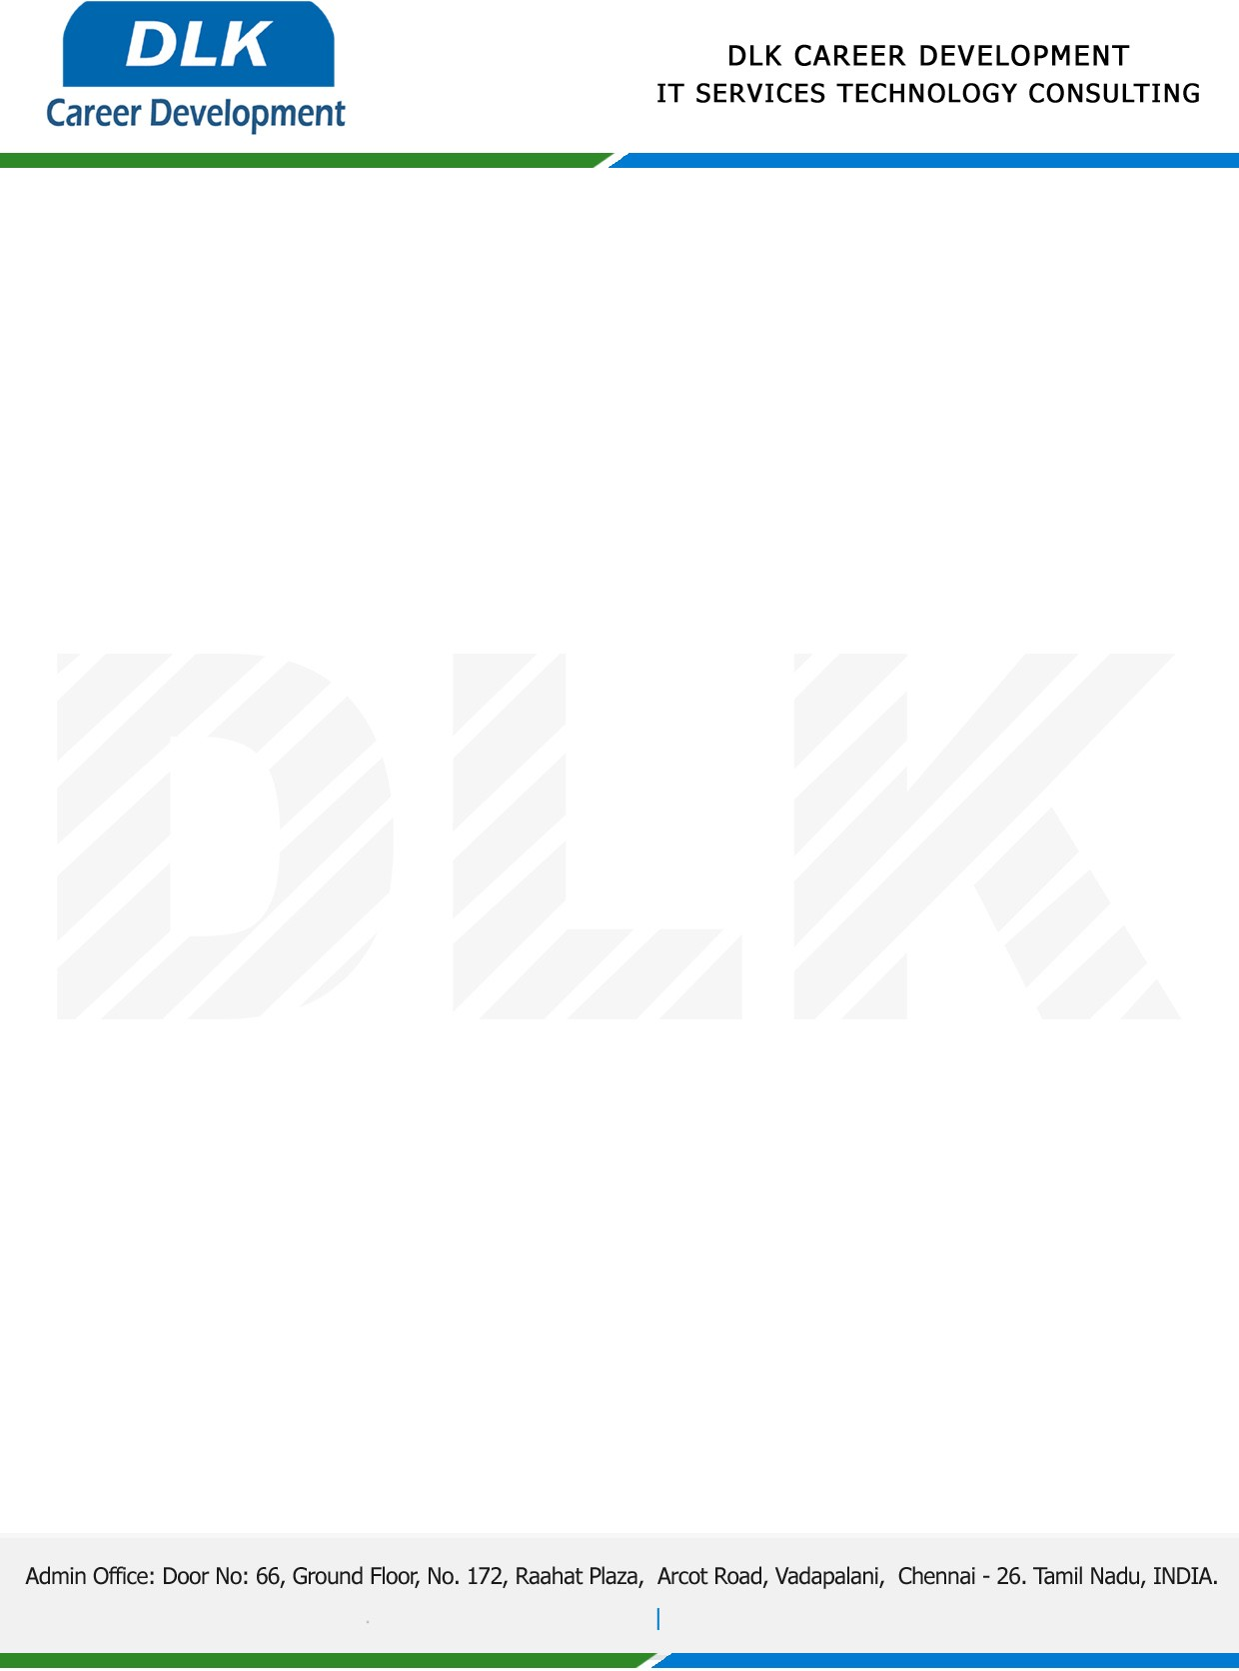

**Date: 20/January /2023**

**SUB: INTERNSHIP COMPLETION CERTIFICATE**

This is to certify that **BBA-**Business Administration**,** final year students of **ST. Thomas College of Arts and Science, Chennai** has Successfully Completed the internship Work under the domain of “**Human Resources”** in our organization during the Period **(09th December 2023 to 09th  January 2023)**.

**Team Members:**

1. MR KARTHICK D (REG NO:412002610)
2. MR KARTHICK R (REG NO:412002612)
3. MR KAALIMUTHU V (REG NO:412002607)

**Topic:** Human Resources Management in Indian IT Companies.

We appreciate your interest in **DLK CAREER DEVELOPMENT**

**“Best Wishes for Your Future Endeavors “**

